Name _____________________________ pd.___ Seat # ___ Color _________________

Sea-floor Spreading
Objective
Students will construct a paper model to illustrate how the seafloor is created at mid-ocean ridges and is removed where it descends into trenches.
Materials
For each pair of students:
- one copy of the sea-floor spreading model pattern
- scissors
- colored pencils (orange, yellow, green, blue)
- tape
Student Procedures
- Cut along the dotted lines of the sea-floor spreading model pattern.
- Color the areas indicated on the two strips with colored pencils.
- Tape together the orange ends of the strips with the colored sides facing each other.
- Thread the two strips through Slit B of the larger sheet. Pull one side down through Slit A and the other through Slit C. (Figure 1)
- Pull the strips through the slits so that the same colors on both strips emerge from Slit B and disappear into Slits A and C at the same time.
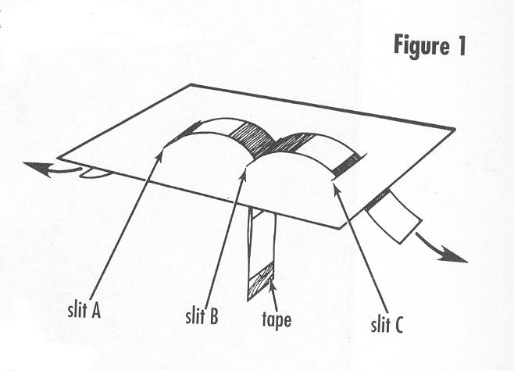
Analyze and Conclude
- What is happening at Slit B? What feature occurs at the corresponding location on the seafloor?

Turn over
- What is happening at Slits A and C? What features occur at the corresponding location on the seafloor?

- If you were to sample and date the rocks along the colored strip starting at Slit B and moving toward Slit A, what change if any would you see in the age of the rocks?

- If you were to sample and date the rocks along the colored strip starting at Slit B and moving toward Slit C, what change if any would you see in the age of the rocks?

- In this model, what do the strips represent? What do the colors represent?

- New seafloor rock is continually being formed at mid-ocean ridges and old seafloor is continually removed at ocean trenches. If the rock on the continents is continually formed but not removed, how would the age of the oldest rocks on the continents compare with the age of the age of the oldest rocks on the seafloor?

- What are the strengths and weaknesses of this model as a model for demonstrating sea-floor spreading?

Reference: Laboratory activity taken from pages 93-99 of Ford, Brent A., Project Earth Science: Geology. Arlington: National Science Teachers Association, 1996.



