**Scientific Method**

**Learning Target: The student will pose scientific questions and suggest investigative approaches to provide answers to questions.**

**Vocabulary:**

* **Hypothesis: proposed explanation for a phenomenon**
* **Independent Variable: the input or causes in the experiment**
* **Dependent Variable: the output or the effect**
* **Controlled Variable or Constants: quantities a scientist wants to stay the same**

**Front**  **Inside Fold**

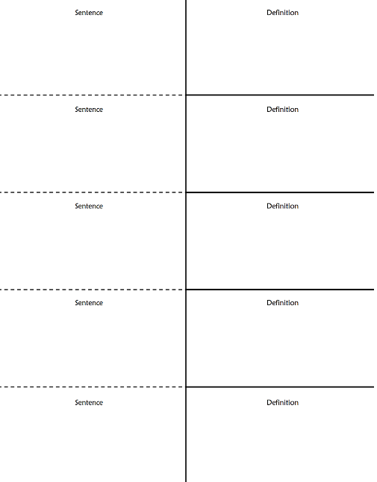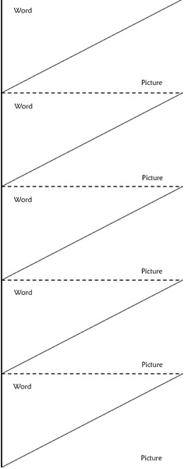

**Objectives covered in class today:**

* **Identify the steps of the scientific method.**
* **Pose research questions and use viable resources to gather background information needed to perform controlled scientific experiments.**
* **Compose possible hypotheses for a scientific investigation given a problem.**
* **Identify independent, dependent and controlled variables for science investigations.**

**Literacy: Use for Background Information in Baking Soda and Vinegar Lab**

***Source 1: http://library.thinkquest.org/3347/vinegar+bsoda4.html***

The experiment baking soda and vinegar is one of the most popular. However, it is deceptively simple: what appears to be one reaction is actually two, happening in quick succession. This reaction is an example of a [multi-step reaction](http://library.thinkquest.org/3347/vinegar+bsoda5.html).

What actually happens is this: the acetic acid (that's what makes vinegar sour) reacts with sodium bicarbonate (a compound that's in baking soda) to form carbonic acid. It's really a [double replacement](http://library.thinkquest.org/3347/reactypes.html#double) reaction. Carbonic acid is [unstable](http://library.thinkquest.org/3347/vinegar+bsoda5.html), and it immediately falls apart into carbon dioxide and water (it's a [decomposition](http://library.thinkquest.org/3347/reactypes.html#decomp) reaction). The bubbles you see from the reaction come from the carbon dioxide escaping the solution that is left. Carbon dioxide is heavier than air, so, it flows almost like water when it overflows the container. It is a gas that you exhale (though in small amounts), because it is a product of the reactions that keep your body going. What's left is a dilute solution of sodium acetate in water.

***Source 2:*** [***http://www.wisegeek.com/in-chemistry-what-is-a-limiting-reactant.htm***](http://www.wisegeek.com/in-chemistry-what-is-a-limiting-reactant.htm)

When a chemist wants to make a certain amount of a product, he needs to know how much of each chemical reactant to use. Similarly, if he has a certain amount of a reactant, it may be useful to find out how much product he will be able to make with it. In chemistry, one of the factors that a chemist will need to know in order to make or determine how much product he can make is the limiting reactant. The limiting reactant, also called a limiting reagent, limits the amount of product that can be made in a reaction—once this reactant is consumed, the reaction will stop. It is important, therefore, that the chemist know how to determine which reactant is the limiting reactant and to ensure he has enough of it to make the desired amount of product.

The limiting reactant is the reactant that will run out first as a reaction progresses. When the limiting reactant is used up, the reaction will cease. Any chemical or substance has the potential to be a limiting reactant. In order to determine which reactant is the limiting one, the chemist will need to determine how much of each substance he has. He will also need to know what proportion of each reactant the reaction needs in order to continue the desired amount of time.

A balanced equation can help a scientist know the proportion of each reactant. A balanced equation is one that reflects the law of conservation—nothing is created or destroyed during the reaction. In other words, there are as many atoms on one side of the equation as there are on the other. For instance, the balanced equation for making water is 2 H2 + O2 = 2 H2O. It is clear here that we need twice as many hydrogen atoms as oxygen atoms to make water.

Before he can determine which reactant is the limiting reactant, a scientist needs to know how many moles of each substance he has. A mole is equal to approximately 6.02 x 1023 units of the substance and weighs the same as the molecular weight of that substance. For instance, since the molecular weight of hydrogen is approximately 2 grams, a mole of hydrogen molecules would also weigh approximately 2 grams and be roughly equal to 6.02 x 1023 molecules of hydrogen. Similarly, the molecular weight of oxygen— approximately 32 grams—is roughly equal to one mole of oxygen molecules. So, if the chemist has two grams of hydrogen and 32 grams of oxygen, he knows that he has about a mole of each substance.

Once the chemist has the proper balanced equation and knows how much of each reactant he has, he can then determine which reactant is the limiting reactant. For example, if the scientist determines he has one mole of hydrogen and one mole of oxygen, hydrogen would be the limiting reactant. Per the balanced equation for making water, you can see that it takes twice as many moles of hydrogen atoms than oxygen atoms to make water. In other words, each oxygen atom needs two hydrogen atoms in order to make water. The hydrogen would run out before the oxygen does, and once that happens, the reaction would stop.

***Source 3: http://rpsec.usca.edu/student/CE-MISTSP/CE-MISTCSIPost.pdf***

Balanced equation for the reaction of Baking Soda (NaHCO3) and Household Vinegar (HC2H3O2):

**Reactant** **Product** **Product**

NaHCO3 (84 grams) + HC2H3O2 (60 grams) ➜ H2CO3 + NaC2H3O2 ➜ H2O + CO2 + NaC2H3O2

**Source 4:** [**https://www.britannica.com/science/collision-theory-chemistry**](https://www.britannica.com/science/collision-theory-chemistry)

**Collision theory,**theory used to predict the rates of chemical reactions, particularly for gases. The collision theory is based on the assumption that for a reaction to occur it is necessary for the reacting species (atoms or molecules) to come together or collide with one another. Not all collisions, however, bring about chemical change. A collision will be effective in producing chemical change only if the species brought together possess a certain minimum value of [internal energy](https://www.britannica.com/science/internal-energy), equal to the [activation energy](https://www.britannica.com/science/activation-energy) of the reaction. Furthermore, the colliding species must be oriented in a manner favourable to the necessary rearrangement of atoms and electrons. Thus, according to the collision theory, the rate at which a [chemical reaction](https://www.britannica.com/science/chemical-reaction) proceeds is equal to the frequency of effective collisions. Because atomic or molecular frequencies of collisions can be calculated with some degree of accuracy only for gases (by application of the kinetic theory), the application of the collision theory is limited to gas-phase reactions.

***Source 5: http://www.webchem.net/notes/how_far/kinetics/rate_factors.htm***

# Factors that Affect the Rate of a Reaction

There are 4 basic factors that can affect the rate of a chemical reaction:

* [Temperature](http://www.webchem.net/notes/how_far/kinetics/rate_factors.htm#1. Temperature)

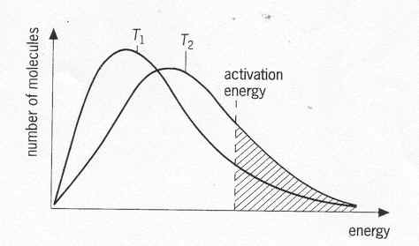

* [Concentration and pressure](http://www.webchem.net/notes/how_far/kinetics/rate_factors.htm#2. Concentration and pressure)
* [Physical state](http://www.webchem.net/notes/how_far/kinetics/rate_factors.htm#3. Physical state)
* [Catalyst](http://www.webchem.net/notes/how_far/kinetics/rate_factors.htm#4. Catalyst)

## 1. Temperature

An increase or decrease in temperature will change the shape of the curve which means fewer or more particles will have the required activation energy.

As the number of molecules is constant so the areas under the 2 curves are the same. BUT, the average energy of the molecules in curve T2 is greater, so there are more particles with enough energy to react. So there are basically 2 factors to consider:

* Increase in energy of particles due to increase in average energy of particles.
* Increase in speed of particles do there are more successful collisions with particles having the required activation energy.
* These two factors result in the rate of the reaction increasing.

## 

## 2. Concentration and pressure

If the concentration or pressure of a chemical increases, there will be more particles within a given space.

* Particles with therefore collide more often
* As concentration or pressure increases, the rate of reaction also increases.

## 

## 3. Physical state

If particles are in the same phase (liquid/liquid) or (gas/gas), then it is very easy for them to mix with each other. This gives particles the maximum opportunity to collide. BUT, if one of the reactants is a solid, then the reaction can only take place on the surface of the solid.

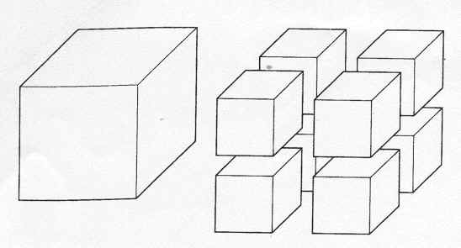

The smaller the size of the solid particles, the greater the area that the reaction can take place in.

So finely divided powder reacts more quickly than the same stuff in a great big lump!

A situation that can arise with a 2 liquids or 2 gases is if they are immiscible (can't mix), this will mean that the reaction can only occur at the interface between the two fluids.

## 4. Catalyst

### What is a catalyst?

A catalyst is a substance that alters the rate of a chemical reaction without being used up or permanently changed chemically.

### How does it work?

A catalyst works by changing the energy pathway for a chemical reaction. It provides an alternative route (mechanism) that lowers the Activation Energy meaning more particles now have the required energy needed to undergo a successful collision.

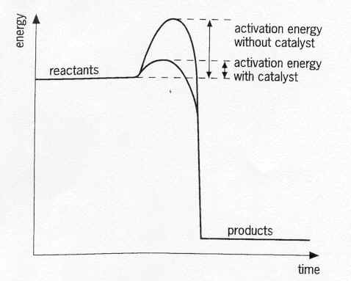

The above graph demonstrates what a catalyst does to the reaction profile. You will be expected to produce one of these!