Atmosphere Mini-Activities
Using the materials around the classroom create a density column to represent the layers of the atmosphere in the glass jar. Create an illustration of your density column next to the picture below labelling the different layers and the substance that represented that layer.
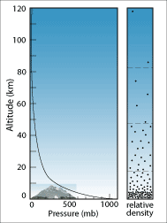

Create a drawing to show the composition of Earth’s Atmosphere.

Create a drawing to show how temperature changes with respect to altitude and latitude. Relate this picture to the distribution of Earth’s biomes.

Create a drawing to show how pressure changes with altitude.

Describe or illustrate a model that demonstrates how relative humidity changes with respect to temperature.

Create a visual to show how vegetation influences humidity.

